English website
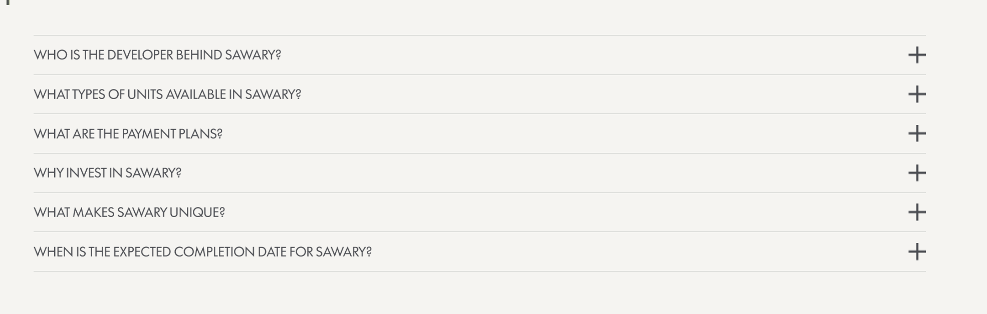
Feedback 1 = Sawari is spelled wrong here

Feedback 2: Replace the answer: Sawari is developed by a team with deep regional real estate expertise, in collaboration with Khatib & Alami, the internationally recognized planning, engineering, and design consultancy behind the project’s masterplan.

Feedback 3:⁠ ⁠Wrong address wording
- The website says: “Ajman, Dubai, United Arab Emirates”.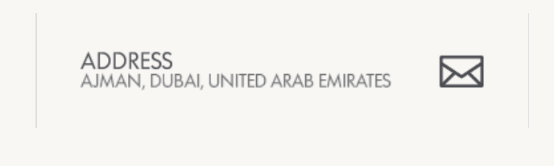
- Should be: Al Zahya, Ajman, United Arab Emirates

Feedback 4 :
- The website says only: Studios, 1-bedroom, and 2-bedroom.
- We need to add a 3BR, 4Bedroom duplex apartment.

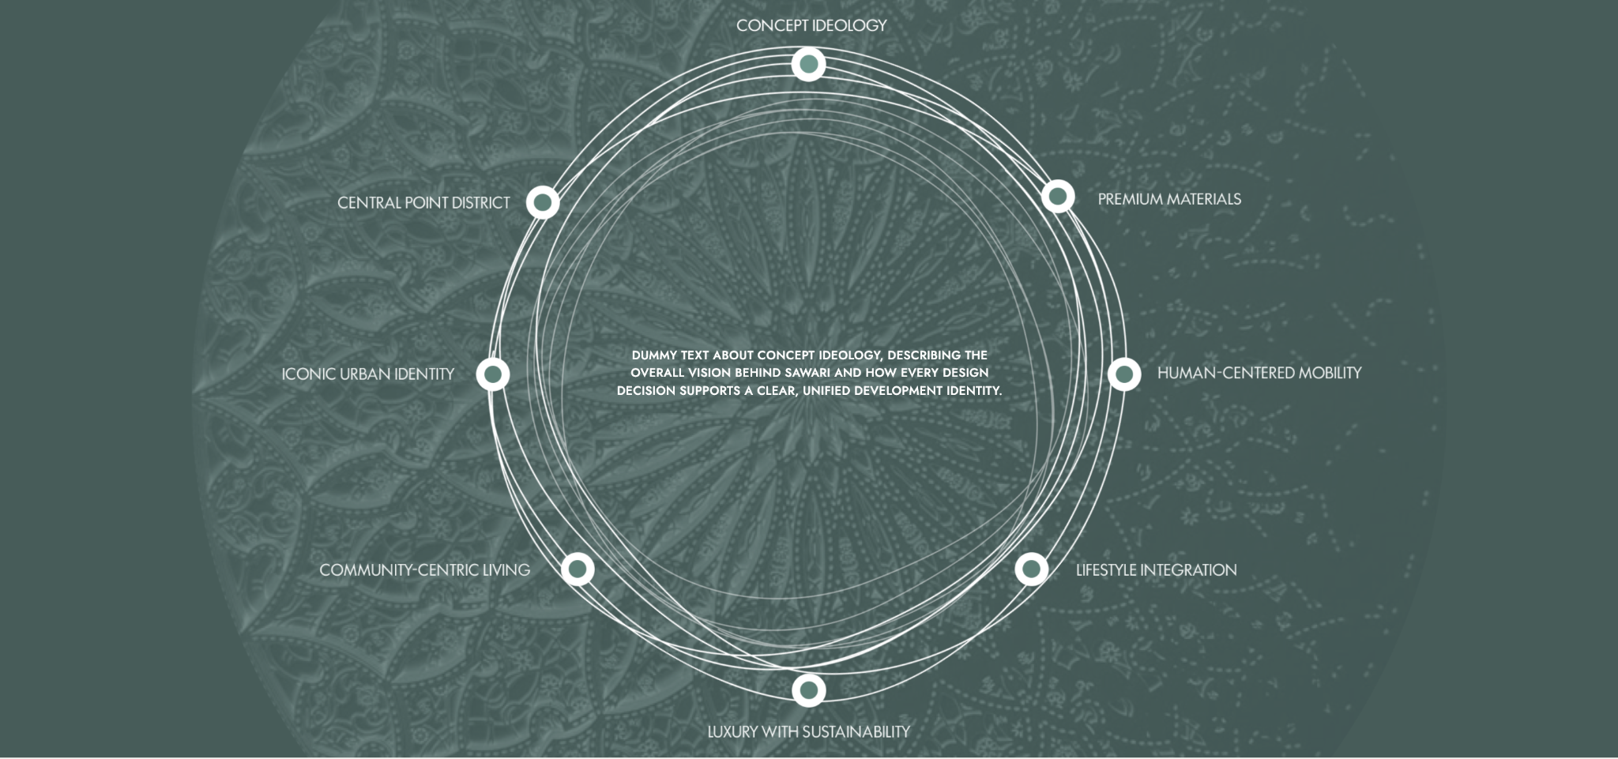
- Feedback 5: The text in the middle should be this - Designed around people, Sawari promotes walkable environments, strong connectivity, and integrated public realms, fostering a dynamic and accessible lifestyle for residents and visitors alike.

- Feedback 6: add 3 bedroom and 4 bedroom

